<https://pcwww.liv.ac.uk/~goodhew/Student%20webs/Hylton%20electronics/Copamp.htm>

1. Waveform: sin wave, square, triangle, random, santoote,

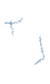V(t) = Asin(wt + phi)



1. Define amplitude:



(vd 1V pk 🡪 2V peak to peak)

A: peak amplitude(Vp) 5V

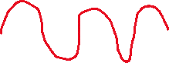

Peak to peak amplitude(Vpp) 10V



Vrms: root mean square(gia tri hieu dung) Vrms = Vp / sqrt(2) (gia tri trung binh cua song sin = 0)

1. Frequency: f = w / 2pi = 1 / T

Priod : the way repeat it self

1. Phase: the shift in time

Lags phase

Lead phase

Phi1 – phi2 < 0 🡪 v1 lags v2

Phi1 – phi2 > 0 🡪 v1 lead v2

How to find: 2 different signal called phase signal, measure the time delay (level must be the same)

Phase v2 = td / T * 360degree=

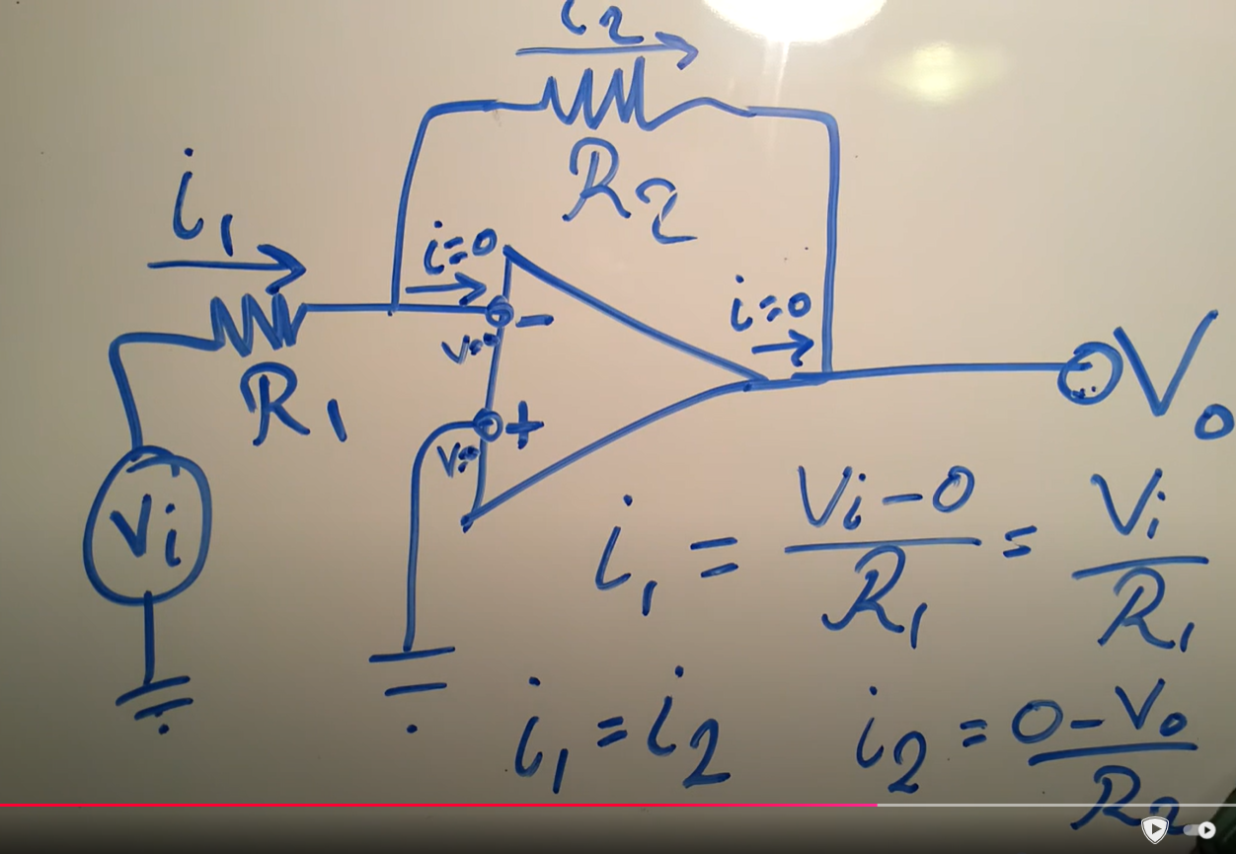

1. Construct the circuit in Fig. 5 with R1 =2.2kΩ, and Rf =10kΩ, 1V input signal at 1Khz. Measure the gain. Sketch the results on the oscilloscope.

2. Calculate and measure the gain with R1 = 2.2kΩ and Rf = 100kΩ. Compare results with previous case. Sketch the results on the oscilloscope.

5.2.1 Construct the non-inverting amplifier shown in Fig. 6 with R1 = 2.2kΩ and Rf = 10kΩ. Measure the gain.

**DO EXPERIMENT**

**Func generation:**

song xoay chieu

Vpp = 10 🡪 Vp = 5

**Oscilloscope:**

1. Mo may len va bam DEFAULT SETUP
2. Ket noi day va kiem tra day (day den cam vao GND)
3. Nhin vao kim do xong gat cai nut qua 10X
4. Kiem tra day bang cach cam vao PROBE COMP se tao ra song vuong (5V@1kHZ)
5. Scale voltage 🡪 theo truc Y, Scale time 🡪 theo truc x

Nut trigger dung de dong bo tan so, mac dinh de 0

Dung cursor de do Voltage Peak, Time

Measure dung de do chinh xac tung gia tri nhu voltage, peak-peak, max(bien do),min,… (NHO PHAI SCALE CHINH XAC THI MAY MOI DO DUNG)

Do chuc nang PHASE de nham lan dau cong, dau tru (Nao len dinh truoc la lead)

Khi gap dau CHAM HOI thi chinh scale voltage lai cho dep (Song phai cao hon 1 o)